**Design and Development of Automatic Smart Crop Protection.**

*Industry oriented mini project report submitted in partial fulfillment of the requirements*

*for the degree of*

**Bachelor of Technology**

in

**Electronics and Communication Engineering**

*Submitted by*

1. **Usha Sree (21B81A04B9)**



**DEPARTMENT OF ELECTRONICS & COMMUNICATION ENGINEERING**

**CVR COLLEGE OF ENGINEERING**

**(An Autonomous Institution & Affiliated to JNTUH)**

**Ibrahimpatnam (M), Ranga Reddy (D), Telangana**

**2024-25Design and Development of Automatic Smart Crop Protection.**

*Industry oriented mini project report submitted in partial fulfillment of the requirements*

*for the degree of*

**Bachelor of Technology**

in

**Electronics and Communication Engineering**

*Submitted by*

1. **Usha Sree (21B81A04B9)**

Under the Supervision of

**Mr. G. Ravi Kumar Reddy**

**Senior Assistant Professor**



**DEPARTMENT OF ELECTRONICS & COMMUNICATION ENGINEERING**

**CVR COLLEGE OF ENGINEERING**

**(An Autonomous Institution & Affiliated to JNTUH)**

**Ibrahimpatnam (M), Ranga Reddy (D), Telangana**

**2024-25**

******Certificate**

|  |  |
| --- | --- |
| **Supervisor**    Mr. G Ravi Kumar Reddy  Sr. Assistant Professor  Dept. of ECE  **Project In-charge**  Dr. G. Ravi Shankar Reddy  Professor  Dept. of ECE  Place:  Date: | **Head of the Department**  Dr. P. Srinivasa Rao  Head of Department  ECE  **External Examiner** |

This is to certify that the project work titled **“Design and Development of Automatic Smart Crop Protection”** submitted to the **CVR College of Engineering**, affiliated to **JNTUH**, by **A.Usha Sree (21B81A04B9)** is a bonafide record of the work done by the students towards partial fulfillment of requirements for the award of the degree of **Bachelor of Technology in Electronics & Communication Engineering** during the academic year 2024-2025.

**DECLARATION**

I hereby declare that this project report titled **“Design and Development of Automatic Smart Crop Protection”** submitted to the Department of Electronics and Communication Engineering, CVR College of Engineering is a record of original work done by me under the guidance of **Mr. G.Ravi Kumar Reddy.** The information and data given in the report is authentic to the best of my knowledge. This project report is not submitted to any other university or institution for the award of any degree or diploma or published any time before.

**T.Sai Vardhan (21B81A04A0)**

**Saniya Sulthana (21B81A04A1)**

**A.Usha Sree (21B81A04B9)**

Date:

Place:

**ACKNOWLEDGEMENT**

The satisfaction that accompanies the successful completion of any task would be incomplete without the mention of the people who made it possible and whose encouragement and guidance has been a source of inspiration throughout the course of the project.

It is great pleasure to convey our profound sense of gratitude to our principal **Dr. K**. **Ramamohan Reddy**, **Dr. P. Srinivasa Rao,** Head of the ECE Department, CVR college of Engineering for having been kind enough for arranging the necessary facilities for executing the project in the college.

We would like to express our sincere gratitude to our supervisor**, Mr. G. Ravi Kumar Reddy, Sr. Assistant Professor**, **ECE Dept**, **CVR College of Engineering,** whose guidance and valuable suggestions have been indispensable to bring about the successful completion of our project.

We wish to acknowledge special thanks to the Project Coordinator **Dr. G. Ravi Shankar Reddy, Professor,** of ECE Dept. for assessing seminars, inspiration, moral support and giving us valuable suggestions in our project.

We would also like to express our gratitude to all the staff members and lab faculty, department of Electronics and Communication Engineering, CVR College of Engineering for the constant help and support.

We wish a deep sense of gratitude and heartfelt thanks to management for providing excellent lab facilities and tools. Finally, we thank all those whose guidance helped us in this regard.

**ABSTRACT**

Agriculture is the backbone of food production, yet crops are frequently threatened by animal intrusions, causing significant damage and loss for farmers. Traditional methods like scarecrows, fences, and manual monitoring are often ineffective, labor-intensive, and costly. The need for a more reliable, automated solution is critical, particularly in remote areas where constant monitoring is not feasible. To address this, an automatic crop protection system is proposed, utilizing modern technology to safeguard crops from animal intrusion and reduce crop loss efficiently

This system is designed using an Arduino ATmega 2560 as the core controller and integrates a range of sensors including ultrasonic sensors for detecting nearby animals, PIR sensors for motion detection, MQ3 for fire detection and air quality monitoring, and a soil moisture sensor to assess soil conditions. A GSM module is incorporated to send real-time alerts to the farmer, enabling immediate action. Upon detecting animals or hazardous conditions, the system autonomously activates deterrents and alerts, offering continuous, cost-effective crop protection with minimal human intervention, significantly improving crop yield and reducing damage.

**Table of Contents**

**Acknowledgement v  
Abstract vi   
Table of Contents vii List of Figures**  **viii**

**Chapter 1 Overview 1**

**Chapter 2 Project Description 4**

**Chapter 3 Advantages and Disadvantages 17**

**Chapter 4 Applications 19**

**Chapter 5 Result 20**

**Chapter 6 Future Scope 22**

**References 24**

**Appendix 25**

**List of Figures**

Figure-2.1: Arduino MEGA 2560

Figure-2.2: PIR Sensor

Figure-2.3: Ultrasonic Sensor

Figure -2.4: Soil Moisture Sensor

Figure-2.5: MQ3 Gas Sensor

Figure -2.6: GSM Module 808

Figure -2.7: Buzzer

Figure-2.8: Arduino IDE Software

Figure-2.9: Block diagram

**CHAPTER 1**

**OVERVIEW**

**1.1 Introduction**

This project focuses on the development of a smart crop protection system, utilizing the Arduino Mega 2560 as the core controller, along with a variety of sensors to provide comprehensive monitoring and protection for agricultural fields. Agriculture plays a crucial role in the global economy, and the need for efficient and intelligent systems to protect crops from environmental threats, pests, and external hazards has never been more critical. Traditional methods of crop monitoring and protection can be labor-intensive and inefficient, especially over large areas. By incorporating sensor-based automation, this system aims to address these challenges, offering a more efficient, real-time approach to managing crop health and security.

The system is equipped with a PIR sensor to detect any motion, such as the presence of animals or unauthorized personnel, potentially harmful to crops. The soil moisture sensor plays a vital role in ensuring optimal water levels in the soil, promoting better crop growth and reducing the chances of under or over-watering. An ultrasonic sensor is used for distance measurement, providing data that can be applied for detecting obstacles or assessing plant height. The MQ3 gas sensor is included to detect the presence of harmful gases like alcohol vapors or pollutants, which may adversely affect crop health. A GSM 808 module allows for remote communication, sending real-time alerts via SMS to inform the farmer of any abnormal conditions or threats detected by the system.

**1.2 Aim**

The aim of the smart crop protection system is to provide an automated, real-time monitoring and alert mechanism for agricultural fields by integrating various sensors and communication technologies. The system seeks to enhance crop security by detecting environmental changes, potential threats from intruders or animals, and harmful gases, while also optimizing irrigation through soil moisture monitoring. By enabling remote communication through a GSM module, the system aims to improve the efficiency and responsiveness of farmers in managing their crops, reducing losses, and ensuring healthier crop growth through timely interventions.

**1.3 Methodology**

The methodology for developing the smart crop protection system involves several key stages, starting with the selection and acquisition of components. Suitable sensors for motion detection (PIR sensor), soil moisture monitoring, distance measurement (ultrasonic sensor), gas detection (MQ3 gas sensor), and communication (GSM 808 module) are chosen, alongside the Arduino Mega 2560 microcontroller for data processing. Following this, a circuit diagram is designed to illustrate the connections between the sensors and the microcontroller, along with a flowchart to outline the system’s operational logic. The next step is software development, where Arduino code is written to initialize the sensors and read data at regular intervals, implementing logic for motion detection, soil moisture thresholds, distance measurement, and gas concentration alerts.

After coding, the hardware components are assembled on a breadboard or custom circuit board for prototyping. Individual sensors are tested to ensure proper functionality, followed by system-level testing to confirm accurate data reporting and effective GSM alert communication. The system is then deployed in an agricultural setting for field testing, allowing for observation of its performance under various environmental conditions. Data collected during this phase is analyzed to assess effectiveness, leading to refinements in sensor thresholds and software logic as needed. Finally, comprehensive documentation of the development process, including circuit diagrams, code, and testing results, is prepared. After successful testing and refinements, the system is deployed for regular use, accompanied by an established maintenance schedule to ensure long-term functionality. This structured methodology aims to create an effective solution for monitoring and protecting crops, ultimately enhancing agricultural productivity and sustainability.

**Hardware Specifications:**

* Arduino Mega 2560
* PIR Sensor
* Soil Moisture Sensor
* Ultrasonic sensor
* GSM Module 808
* MQ3 Gas Sensor
* Buzzer

**Software Specifications:**

* Arduino IDE

**1.4 Significance of the Work**

The significance of the smart crop protection system lies in its ability to enhance agricultural practices through real-time monitoring and protection of crops. By integrating various sensors and communication technologies, the system provides farmers with critical information, enabling timely interventions to prevent crop loss due to pests, diseases, or adverse weather. This promotes precision agriculture, optimizing resource use such as water and fertilizers, thereby improving crop yield while reducing waste and environmental impact. Additionally, the ability to receive remote alerts empowers farmers to make informed decisions efficiently, contributing to sustainable farming practices and enhancing food security. Overall, this system represents a significant advancement in modern agricultural techniques.

**CHAPTER 2**

**PROJECT DESCRIPTION**

**2.1 Introduction**

This project focuses on the development of a smart crop protection system that leverages modern technology to enhance agricultural practices through real-time monitoring and protection of crops. As the global population continues to grow, the demand for food increases, necessitating innovative solutions to improve agricultural productivity while minimizing environmental impact. Traditional farming methods often face significant challenges, including pest invasions, disease outbreaks, water scarcity, and the need for efficient resource management. In response to these challenges, this project aims to create an intelligent, automated system capable of providing farmers with critical information about their crops and the surrounding environment.

At the heart of this system is the Arduino Mega 2560 microcontroller, chosen for its versatility and ability to handle multiple sensor inputs simultaneously. The integration of a variety of sensors is essential to monitor different aspects of crop health and safety. A PIR sensor is utilized for motion detection, enabling the system to identify potential threats from animals or intruders that could damage crops. The soil moisture sensor plays a crucial role in monitoring hydration levels, ensuring that crops receive adequate water while preventing over-irrigation, which can lead to root rot and other issues. An ultrasonic sensor is included for distance measurement, allowing the system to detect obstacles or measure plant height accurately. Additionally, the MQ3 gas sensor is employed to monitor the presence of harmful gases, such as alcohol or pollutants, that may negatively impact crop health.

To facilitate real-time communication and remote monitoring, a GSM 808 module is integrated into the system. This module allows the smart crop protection system to send alerts and updates via SMS, empowering farmers to make informed decisions quickly, even when they are not physically present in the field. By receiving timely notifications about motion detection, soil moisture levels, or the presence of harmful gases, farmers can take appropriate actions to protect their crops, such as adjusting irrigation schedules or addressing security concerns.

The significance of this project extends beyond mere convenience; it represents a step towards precision agriculture, where data-driven decisions enhance crop management. By optimizing resource use, such as water and fertilizers, farmers can increase crop yields while reducing waste and environmental degradation. The automated nature of this system also minimizes the labor required for monitoring, allowing farmers to focus on other critical aspects of their operations.

Furthermore, this smart crop protection system has the potential to contribute to sustainable farming practices. By enabling more efficient use of resources and minimizing the reliance on chemical pesticides, the system promotes healthier crop growth and reduces the impact of agriculture on the surrounding ecosystem. As a result, the project not only addresses the immediate challenges faced by farmers but also aligns with broader goals of food security and environmental stewardship.

**Hardware and Software:**

**a)Arduino Mega 2560**

The Arduino Mega 2560 is a powerful microcontroller board designed for complex and large-scale projects, featuring the ATmega2560 microcontroller. It offers 54 digital I/O pins and 16 analog inputs, making it ideal for integrating multiple sensors and controlling various devices simultaneously. With 256 KB of flash memory, 8 KB of SRAM, and 4 KB of EEPROM, the board can handle large programs and complex data processing tasks, essential for real-time monitoring systems like smart crop protection. Its support for multiple communication protocols, including four hardware serial ports (UART), SPI, and I2C, allows seamless integration with modules like GSM for remote communication and other external devices. The board can be powered via USB or an external power source, making it flexible for both prototyping and field deployment. Its compatibility with various shields and modules, such as those for Ethernet or wireless communication, enhances its expandability, making it a popular choice for IoT applications. In smart crop protection systems, the Arduino Mega 2560 facilitates the integration of sensors like motion detectors, soil moisture sensors, and gas sensors, allowing farmers to monitor and manage their crops more efficiently while receiving real-time alerts via GSM. Its versatility, memory capacity, and robust performance make it an essential tool for developing advanced, scalable agricultural solutions.

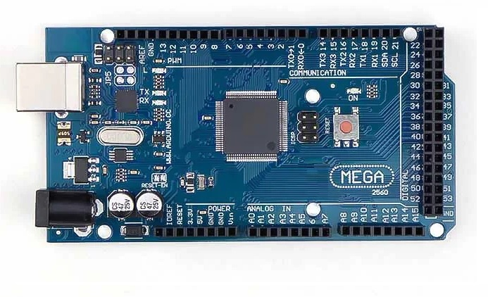

**Figure-2.1: Arduino Mega 2560**

**b) PIR Sensor**

A [passive infrared sensor](https://robu.in/product/pir-motion-sensor-detector-module-hc-sr501/) is an electronic sensor that measures infrared light radiating from objects. PIR sensors mostly used in PIR-based motion detectors. Also, it used in security alarms and automatic lighting applications. The below image shows a typical pin configuration of the PIR sensor, which is quite simple to understand the pinouts. The PIR sensor consist of 3 pins.

* Pin1 corresponds to the drain terminal of the device, which connected to the positive supply 5V DC.
* Pin2 corresponds to the source terminal of the device, which connects to the ground terminal via a 100K or 47K resistor. The Pin2 is the output pin of the sensor. The pin 2 of the sensor carries the detected IR signal to an amplifier from the
* Pin3 of the sensor connected to the ground.

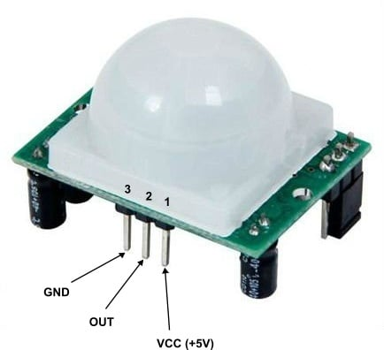

**Figure-2.2: PIR Sensor**

**c) Ultrasonic Sensor**

An ultrasonic sensor is a device that measures distance by emitting ultrasonic sound waves and calculating the time it takes for the waves to bounce back from an object. It is widely used in applications requiring non-contact distance measurement, such as obstacle detection, proximity sensing, and liquid level monitoring. The sensor works by sending out a high-frequency sound wave through its transmitter, which reflects off nearby objects, and the sensor’s receiver then captures the returning echo. By calculating the time between the emission and reception of the sound wave, the sensor determines the distance to the object. Ultrasonic sensors are accurate, reliable, and can measure distances ranging from a few centimeters to several meters. They are commonly used in robotics, automation, and IoT applications due to their versatility, ease of integration, and low cost. In a smart crop protection system, an ultrasonic sensor can monitor for obstacles or animals that may threaten crops, measure plant height, or help automate systems like irrigation, offering a practical solution for enhancing efficiency in agriculture.

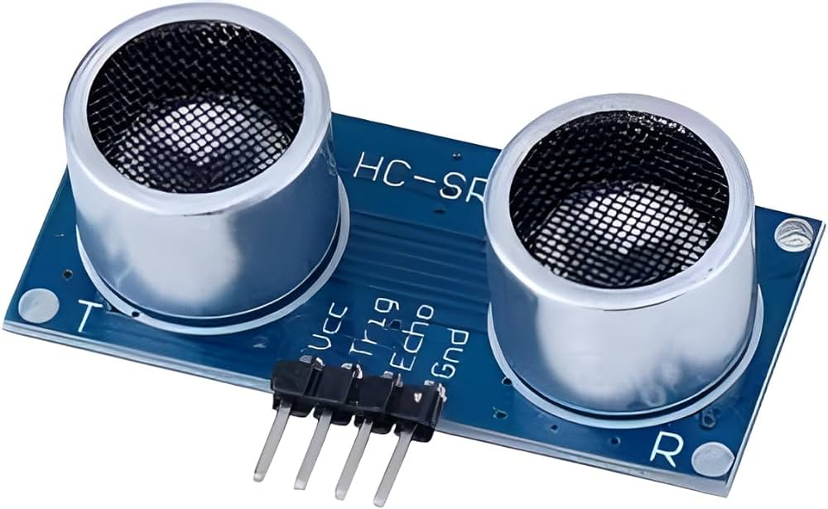

**Figure-2.3: Ultrasonic Sensor**

**d) Soil Moisture Sensor**

A soil moisture sensor is a device designed to measure the water content in soil, playing a crucial role in agriculture, gardening, and environmental monitoring. There are several types of sensors, including capacitive sensors, which measure the dielectric constant of the soil, and resistive sensors, which assess electrical resistance between electrodes. Tensiometers measure the tension of water in the soil, while Time Domain Reflectometry (TDR) uses pulse travel time to determine moisture levels, offering high accuracy. Key features to consider include calibration needs, data output options for real-time monitoring, and durability to withstand various environmental conditions. Applications range from optimizing irrigation schedules in agriculture to maintaining healthy landscapes and conducting ecological research. When selecting a soil moisture sensor, it's essential to consider your specific needs, such as the type of plants and the environmental context, to ensure the best choice for effective moisture management.

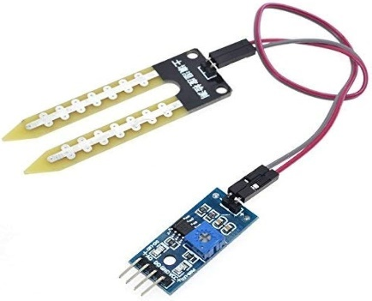

**Figure-2.4: Soil Moisture Sensor**

**e) MQ3 Gas Sensor**

A gas sensor is a device that detects and measures the presence of specific gases in an environment, playing a vital role in applications such as industrial safety, environmental monitoring, and indoor air quality management. There are various types of gas sensors, including electrochemical sensors, which detect gases through chemical reactions and are commonly used for toxic gases like carbon monoxide (CO) and hydrogen sulfide (H₂S); semiconductor sensors, which measure changes in electrical resistance for volatile organic compounds (VOCs) and ammonia (NH₃); infrared sensors that utilize infrared light to identify gases like carbon dioxide (CO₂) and methane (CH₄) through absorption; and photoionization detectors (PIDs) that use ultraviolet light to ionize gas molecules, effectively detecting low concentrations of VOCs. Key features to consider when selecting a gas sensor include sensitivity, response time, calibration needs, and durability for various environments. Overall, gas sensors are essential for ensuring safety and monitoring air quality, and choosing the right type depends on the specific gases to be detected and the operating conditions.

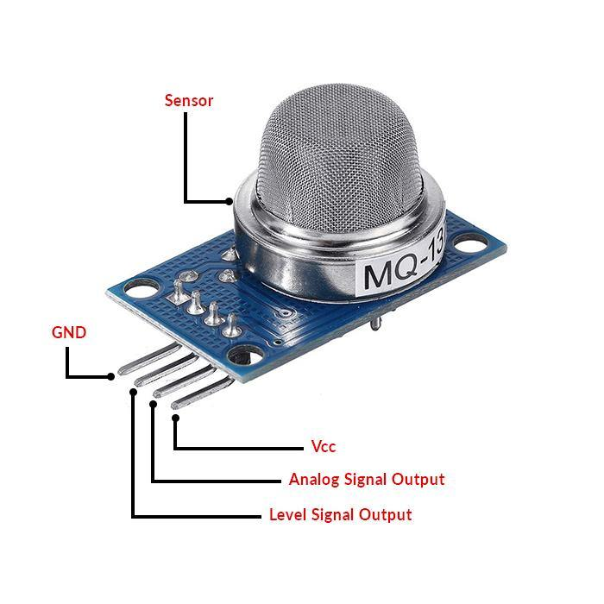

**Figure-2.5: MQ3 Gas Sensor**

**f) GSM Module 808**

The GSM 808 module is an essential component for modern communication in various IoT and automation applications, enabling microcontrollers like Arduino to interface with GSM networks seamlessly. This module supports multiple communication methods, including SMS, voice calls, and internet access via GPRS (General Packet Radio Service), making it highly versatile for remote monitoring and control tasks. Operating on a voltage range of 3.4V to 4.4V, it is compatible with a variety of SIM cards and cellular networks, ensuring broad applicability in diverse geographic locations. The GSM 808 module utilizes standardized AT (Attention) commands for control, allowing users to send and receive messages, initiate calls, and manage data connections easily. With built-in features such as microcontroller integration in some versions, it can perform basic tasks independently or be paired with external controllers for more complex functions. This capability is particularly valuable in smart crop protection systems, where real-time alerts regarding potential threats like animal intrusions, low soil moisture, or hazardous gas levels are crucial for timely intervention. By sending SMS notifications directly to farmers' mobile devices, the GSM 808 module enhances situational awareness, allowing for immediate responses to protect crops from damage. Additionally, it enables farmers to remotely manage their systems through SMS commands, controlling irrigation, activating deterrent measures, or checking the operational status of sensors. The module’s combination of SMS capabilities and GPRS internet connectivity facilitates comprehensive monitoring and management solutions, making it a key component in advancing precision agriculture. Overall, the GSM 808 module significantly contributes to increased efficiency, productivity, and sustainability in agricultural practices, allowing farmers to leverage technology for improved crop management and protection strategies.

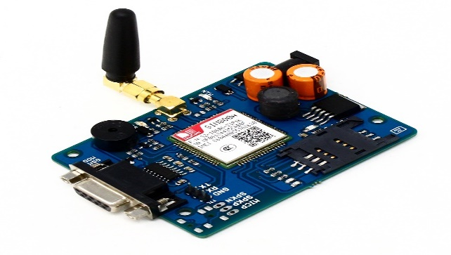

**Figure-2.6: GSM Module 808**

**g) Buzzer**

A buzzer is an essential electronic component that emits sound and is widely used in various applications, including alarms, notifications, and indicators. Buzzers can be categorized into two main types: active and passive. Active buzzers produce sound when powered, while passive buzzers require an external audio signal, such as a square wave, to generate sound. They are designed to operate at low voltages, typically between 5V and 12V, and consume minimal current, making them easy to integrate with microcontrollers and other electronic systems. Buzzers are known for their durability and simplicity; they usually require just two connections one to power and one to ground allowing for straightforward implementation in circuits. Their versatility allows them to be employed in alarms for security systems, notifications in home appliances, indicators in various devices, and feedback mechanisms in user interfaces. In the context of a smart crop protection system, a buzzer plays a crucial role in alerting farmers to critical conditions that require immediate attention. For instance, when a PIR sensor detects motion from potential intruders like animals, the buzzer can emit a loud sound to deter them. Additionally, if soil moisture levels drop below a specified threshold, the system can activate the buzzer to notify the farmer of the need for irrigation. By providing audible alerts, the buzzer enhances the effectiveness of the smart crop protection system, ensuring timely responses to threats and facilitating better resource management, ultimately contributing to improved agricultural productivity and sustainability.

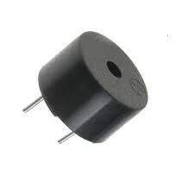

**Figure-2.7: Buzzer**

**Software:**

**Arduino IDE:**

The Arduino IDE (Integrated Development Environment) is a software platform used to write, compile, and upload code (sketches) to Arduino boards. It provides an intuitive interface where users can write code in a text editor with features like syntax highlighting and auto-indentation. The IDE includes a library manager to easily manage and include libraries in projects, and a board manager to select the appropriate Arduino board (e.g., Arduino Uno, Mega 2560). A key feature is the serial monitor, which allows for communication between the board and the computer, enabling users to receive and send messages. The IDE supports debugging, allowing basic issue tracking for both code and hardware. To upload the code to the board, users select the appropriate communication port and hit the upload button. A typical Arduino sketch consists of two main functions: setup(), which runs once when the board is powered on or reset, and loop(), which runs continuously as long as the board is powered. For projects like your smart crop protection system using sensors (PIR, ultrasonic, MQ3 gas sensor) and a GSM module with the Arduino Mega 2560, the Arduino IDE will serve as the central platform for coding and integrating these components.

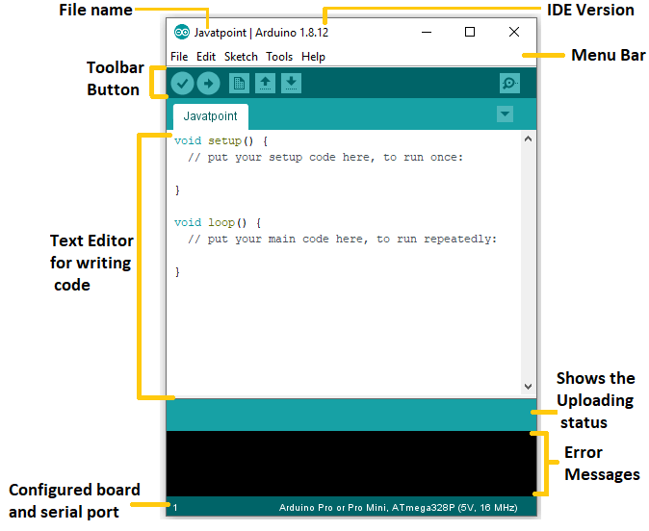

Figure-2.8: Arduino IDE Software

**2.2. WORKING**

**BLOCK DIAGRAM:**

GSM Module

5v Power supply Power Supply

PIR Sensor

Arduino Mega 25602560

Soil moisture Sensor

Buzzer

LED

Ultrasonic sensor

se

MQ3 Gas Sensor

**Figure-2.8: Block diagram**

The block diagram represents a system centered around the Arduino Mega 2560 microcontroller, which acts as the main processing unit. The system integrates several input sensors such as a PIR sensor for motion detection, a soil moisture sensor for monitoring soil hydration levels, an ultrasonic sensor for measuring distances, and an MQ3 gas sensor for detecting gases like alcohol. These sensors provide real-time data to the Arduino, which processes the inputs and triggers appropriate outputs. The system includes a buzzer for audible alerts and an LED for visual indications. Additionally, a GSM module, powered by a 5V power supply, allows the system to send data or alerts via SMS, making it possible to remotely monitor the environment. This design is suitable for applications like home security, environmental monitoring, and automation systems.

**2.2.1. BRIEFING GENERAL BLOCK DIAGRAM**

The block diagram outlines a multi-functional system designed for monitoring various environmental and security parameters, controlled by the Arduino Mega 2560 microcontroller. The choice of the Arduino Mega 2560 is particularly significant for this system due to its 54 digital I/O pins, 16 analog inputs, and ample processing power, making it suitable for handling multiple sensors and output components simultaneously. This high-performance microcontroller processes input data from various sensors in real-time, enabling the system to respond immediately to changes in the environment. It’s a versatile platform, allowing the integration of numerous peripheral devices, which enhances the system’s scalability and adaptability for a wide range of applications such as security systems, smart farming, and industrial monitoring.

At the heart of this system’s sensor suite is the PIR (Passive Infrared) Sensor, which is responsible for detecting motion by measuring the infrared radiation emitted by objects, particularly humans and animals. The PIR sensor is highly sensitive to movement within its detection range, making it ideal for security applications. Upon detecting movement, the PIR sensor sends a signal to the Arduino, which can then trigger a response such as sounding an alarm, lighting up an LED, or sending a notification through the GSM module. This sensor is crucial in home security systems, where it can detect intrusions and send immediate alerts, helping prevent unauthorized access or theft. The non-contact nature of the PIR sensor makes it a reliable and maintenance-free option for continuous monitoring in security applications.

The Soil Moisture Sensor included in the system plays an essential role in smart agriculture. This sensor continuously monitors the water content of the soil, providing critical data for irrigation management. By measuring the electrical conductivity of the soil, the sensor can determine whether the soil is too dry or too wet. This data is processed by the Arduino, which can either trigger an irrigation system if the soil is too dry or send an alert to the user via the GSM module. The system can be programmed to maintain optimal soil moisture levels, reducing water wastage and ensuring better crop yields. This makes the system ideal for agricultural applications where efficient water use is critical, particularly in areas facing water scarcity. In addition to agriculture, this sensor can also be used in smart gardening systems, where homeowners can monitor and manage their garden’s watering schedule remotely, ensuring plants remain healthy without manual intervention.

The Ultrasonic Sensor incorporated into the system is designed to measure distances by emitting ultrasonic sound waves and calculating the time taken for the sound to reflect back after hitting an object. This sensor is widely used in applications like obstacle detection in robotics, proximity sensing in industrial automation, and level measurement in tanks or silos. In this system, the ultrasonic sensor could be used in security scenarios, where it can detect the approach of objects or individuals from a certain distance, triggering an alarm or sending a remote alert when the detected object crosses a predefined distance threshold. Its ability to measure distance accurately and in real-time makes it invaluable in scenarios where precision and immediate response are required. Moreover, the ultrasonic sensor is useful in environments where visual detection may be challenging, such as dark or dusty areas, enhancing the system’s overall robustness in different environments.

The MQ3 Gas Sensor adds a critical safety function to the system by detecting the presence of gases, specifically alcohol vapors, making it suitable for applications where gas leakage could pose a danger. The MQ3 sensor operates by measuring the concentration of gases in the air and sending this data to the Arduino for analysis. If the gas concentration exceeds a safe threshold, the system can trigger a local alert using the buzzer and LED, as well as a remote alert via the GSM module. This feature is especially useful in industrial environments, laboratories, or kitchens where gas leaks can lead to fires, explosions, or health hazards. The MQ3 sensor’s sensitivity to gases makes it a critical component in any system focused on environmental safety, providing early detection that can prevent potentially catastrophic events.

For alerting purposes, the system features both a Buzzer and an LED. The buzzer provides an audible alert when a certain condition is met, such as detecting motion through the PIR sensor, low soil moisture, or high gas concentrations. This immediate audio feedback ensures that anyone nearby is made aware of the situation, making it especially useful in security applications where loud alarms can deter intruders. The LED, on the other hand, offers a visual indication of the system’s status. It can be programmed to light up when specific sensors are triggered, providing a clear and simple way to indicate whether the system is active, armed, or in an alert state. This combination of both visual and audio feedback mechanisms ensures that the system can effectively communicate alerts in different scenarios, catering to both immediate physical responses and remote notifications.

A key feature of this system is its GSM Module, which allows for real-time remote communication. This module enables the system to send text messages (SMS) to the user’s mobile phone when critical conditions are detected, such as motion, gas leaks, or abnormal soil moisture levels. The GSM module operates on a 5V power supply, ensuring reliable communication even when the user is far away from the monitored site. This capability is particularly important in scenarios where the user cannot be physically present to monitor the system, such as in smart farming applications where farmers can receive alerts about soil moisture levels or in home security systems where homeowners can receive notifications of potential intrusions while they are away. The GSM module’s integration makes this system not only a local monitoring solution but also a remote one, significantly enhancing its functionality and appeal**.**

The 5V Power Supply ensures that the entire system runs smoothly, providing stable power to both the Arduino and the GSM module. Since the system needs to be operational at all times, especially for applications like security and environmental monitoring, the reliability of the power supply is crucial. In environments where power outages are a concern, backup power solutions such as battery packs or solar panels can be integrated to ensure continuous operation. A stable and reliable power supply is the foundation of this system, allowing all components to function optimally and ensuring that the system can continuously monitor and respond to environmental changes.

**CHAPTER 3**

**ADVANTAGES AND DISADVANTAGES**

**3.1 Advantages**

**1. User-Friendly Interface:** The Arduino IDE has a simple and intuitive interface that is accessible to beginners while still being useful for experienced developers. This ease of use helps streamline the development process.

**2.Cross-Platform Compatibility:** It runs on various operating systems, including Windows, macOS, and Linux, allowing users to develop on their preferred platform without any compatibility issues.

**3.Open-Source Software:** Being open-source means that users can modify the IDE to suit their needs. This openness also fosters a large community that contributes libraries, examples, and tutorials.

**4. Extensive Library Support:** The IDE supports a vast range of libraries, which simplifies the integration of various hardware components like sensors, motors, and communication modules. This saves time and reduces the need for extensive coding.

**5.Active Community and Resources:** The Arduino community is large and active, providing extensive online resources, forums, tutorials, and example projects. This wealth of information is beneficial for troubleshooting and inspiration.

**6.Real-Time Serial Communication:** The built-in Serial Monitor allows for easy communication with the Arduino board, enabling users to debug their code and monitor sensor data in real-time. This feature is crucial for testing and refining projects.

**7.Simplified Coding:** The IDE uses a simplified version of C/C++, making it easier for beginners to learn programming concepts without being overwhelmed by complex syntax.

**8.Wide Range of Compatible Hardware:** Arduino supports a vast array of boards and shields, making it versatile for various projects. This flexibility allows users to select the best hardware for their specific needs.

**9.Integrated Development Environment:** With features like code editing, compiling, and uploading all in one place, the Arduino IDE simplifies the workflow, making it easier to manage projects from start to finish.

**10.Cloud-Based Options:** The Arduino Web Editor allows users to work from any device with internet access, making it convenient to store and share sketches and access the latest updates automatically.

**3.2 Disadvantages**

**1. Limited Debugging Tools:** The debugging capabilities of the Arduino IDE are quite basic compared to more advanced IDEs. It lacks features like breakpoints and step-through debugging, making it challenging to troubleshoot complex programs.

**2.No Built-in Code Completion:** The IDE lacks advanced code completion features, which can slow down coding for users who are accustomed to more sophisticated environments that offer suggestions and auto-completion.

**3.File Management:** The IDE does not have advanced file management features, making it difficult to organize larger projects that involve multiple files. Users often have to manually manage their code outside the IDE.

**4.Performance Issues:** For very large projects or those involving extensive libraries, the IDE may experience performance issues or become sluggish, particularly on lower-end computers.

**5.Learning Curve for Advanced Features:** While the basic features are user-friendly, advanced functionalities (like using libraries or understanding the nuances of the Arduino programming language) can still present a learning curve for beginners.

**6.Limited Integrated Development Features:** The IDE lacks integrated features like version control, which can complicate collaborative projects and code management. Users often need to rely on external tools like Git for version control.

**CHAPTER 4**

**APPLICATIONS**

**Applications:**

**1.Home Security Systems:** The integration of the PIR sensor makes this system suitable for home security. It can detect motion within a specific area and trigger alarms (via the buzzer) or send SMS alerts (via the GSM module) to homeowners. This real-time detection and alerting can help prevent unauthorized entry, theft, or burglary. The ultrasonic sensor can also be used to detect intruders approaching from a distance, adding an extra layer of security.

**2.Smart Agriculture and Irrigation Systems:** The soil moisture sensor makes this system ideal for smart farming applications. It can continuously monitor the soil’s moisture content and trigger irrigation systems when necessary. Farmers can receive remote notifications about the soil's moisture levels through the GSM module, allowing them to take action from a distance. This leads to water conservation, optimized irrigation, and better crop management, which is especially valuable in water-scarce regions.

**3.Industrial Safety and Gas Leak Detection:** The MQ3 gas sensor makes this system highly applicable in industrial environments where gas leaks pose a significant safety risk. In factories, refineries, and chemical plants, gas leaks can lead to explosions, fires, or health hazards. This system can detect dangerous gas levels and trigger alarms or send remote alerts to safety personnel, allowing for quick responses to prevent accidents.

**4.Environmental Monitoring Systems:** With its various sensors, this system can be deployed for environmental monitoring in various settings. The gas sensor can detect air quality or pollution, while the ultrasonic sensor can measure distances in water bodies or tanks for flood or liquid level monitoring. The system can provide real-time data and alerts to environmental agencies or individuals monitoring natural resources or industrial processes.

**5. Fire and Hazard Detection Systems:** This system can be part of a fire detection or hazard prevention system where gas leaks (monitored by the MQ3 sensor) can be detected early. The system can trigger alarms and send alerts to local fire departments or building managers, ensuring that corrective measures are taken before a small leak escalates into a significant fire hazard.

**CHAPTER 5**

**RESULT**

The multi-sensor monitoring and alert system represented in the block diagram offers a robust and versatile solution for a wide array of applications across diverse fields, including home security, agriculture, industrial safety, environmental monitoring, and smart city initiatives. Its integration of multiple sensors—such as PIR, soil moisture, ultrasonic, and gas sensors—enables real-time data collection and analysis, facilitating proactive responses to environmental changes and potential hazards. The incorporation of a GSM module allows for remote notifications, ensuring that users can stay informed and take timely action, regardless of their physical location.

This system not only enhances security and safety measures but also promotes efficient resource management, particularly in agricultural settings where water conservation is crucial. Its adaptability makes it suitable for both residential and industrial use, providing essential monitoring capabilities that can significantly improve operational efficiency and safety standards. As technology continues to evolve, such multi-functional systems are likely to play an increasingly important role in the development of smart homes, sustainable agriculture, and urban infrastructure, ultimately contributing to enhanced quality of life and environmental stewardship. The flexibility and scalability of this monitoring system position it as a valuable asset in today’s interconnected and rapidly changing world, where timely information and effective response mechanisms are essential for safeguarding both people and resources.

**Observations:-**

|  |  |  |  |
| --- | --- | --- | --- |
| Date&Time | **Sensors** | **Data values** | **output** |
| 6.00 AM | Ultra sonic sensor | 4cm | No object is detected |
| Soil moisture sensor | 650 | Soil is wet buzzer off |
| PIR sensor | No Object passed | Motion not detected buzzer off |
| GAS sensor | 200ppm | No Fire detected Buzzer off |
| 12.00 PM | Ultra sonic sensor | 12cm | Object is detected Buzzer on |
| Soil moisture sensor | 550 | Soil is dry buzzer on |
| PIR sensor | Object passed | Motion detected buzzer on |
| GAS sensor | 300ppm | Fire detected buzzer on call to owner |
| 6.00 PM | Ultra sonic sensor | 15cm | Object detected Buzzer on |
| Soil moisture sensor | 700 | Soil is wet buzzer off |
| PIR sensor | Object passed | Motion detected LED on |
| GAS sensor | 180ppm | No Fire detected |

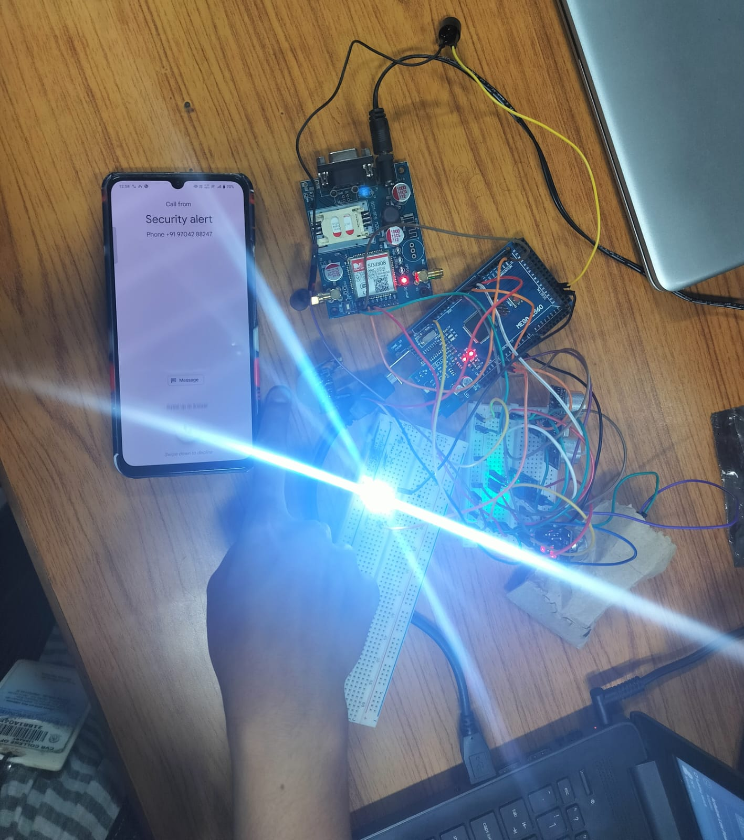

**CHAPTER 6**

**FUTURE SCOPE**

**1.Integration with IoT Platforms:** The system can be enhanced by integrating with Internet of Things (IoT) platforms, allowing for cloud connectivity, data analytics, and machine learning applications. This integration can facilitate more sophisticated data analysis, predictive maintenance, and the ability to manage multiple devices remotely through a centralized dashboard.

**2. Enhanced Data Analytics and AI Integration:** Implementing artificial intelligence (AI) and machine learning algorithms can enable the system to learn from historical data, improving its accuracy in detecting anomalies and predicting potential issues before they occur. For instance, the system could analyze patterns in soil moisture data to optimize irrigation schedules based on weather forecasts.

**3. Expanded Sensor Capabilities:** The addition of new sensors could enhance the system’s functionality. For example, integrating environmental sensors to measure temperature, humidity, and air quality could further improve agricultural monitoring, home automation, and industrial safety applications. Advanced sensors could also be developed to detect specific gases or chemicals relevant to various industries.

**4. Smart City Applications:** As cities become increasingly smart, this monitoring system could be adapted for use in urban infrastructure, providing real-time data for traffic management, public safety, and environmental monitoring. The system could help in monitoring air quality, managing waste, and optimizing resource usage in smart city initiatives.

**5. Integration with Renewable Energy Sources:** The system could be enhanced to work with renewable energy sources, such as solar panels or wind turbines. By monitoring energy production and consumption, it could optimize energy usage in homes and businesses, contributing to sustainability goals.

**5. Modular Design for Customization:** Continuing to develop a modular approach will allow users to customize the system based on specific needs. This flexibility will attract a broader range of applications, from simple home security setups to complex industrial monitoring solutions.

**6. User-Friendly Interfaces:** Developing user-friendly mobile and web applications will enhance user engagement and control over the system. These interfaces could provide real-time data visualization, alerts, and customizable settings to suit individual user needs.

**7. Remote Support and Maintenance:** Incorporating features for remote diagnostics and maintenance can enhance the system's reliability. Technicians could monitor system performance and troubleshoot issues remotely, reducing downtime and ensuring continuous operation.

**8.Disaster Management Systems:** The system can be adapted for use in disaster management, providing real-time alerts for natural disasters such as floods, earthquakes, or fires. Enhanced monitoring capabilities can help in early warning systems, enabling timely evacuations and resource allocation.

.

**REFERENCES**

1. Yoo, Seong-eun, et al. "A 2 S: automated agriculture system based on WSN." *2007 IEEE International Symposium on Consumer Electronics*. IEEE, 2007.

2. Maraiya, Kiran, Kamal Kant, and Nitin Gupta. "Wireless sensor network: a review on data aggregation." *International Journal of Scientific & Engineering Research* 2.4 (2011): 1-6.

3. Babaa, Saleh Elkelani, et al. "Smart irrigation system using arduino with solar power." *International journal of engineering research & technology (ijert)* 9.05 (2020): 7..

4. Thirrunavukkarasu, R. R., et al. "Smart irrigation and crop protection using arduino." *2021 7th International Conference on Advanced Computing and Communication Systems (ICACCS)*. Vol. 1. IEEE, 2021.

5. Vikhram, B., et al. "Animal detection system in farm areas." *International Journal of Advanced Research in Computer and Communication Engineering* 6.3 (2017).

6. Bavane, Vikas, et al. "Protection of crops from wild animals using Intelligent Surveillance System." *International Journal of Research in Advent Technology (IJRAT)* (2018): 2321-9637.

7. Gondchawar, Nikesh, and R. S. Kawitkar. "IoT based smart agriculture." *International Journal of advanced research in Computer and Communication Engineering* 5.6 (2016): 838-842.

8. Sen, Snigdha, and B. Madhu. "International journal of engineering sciences & research technology smart agriculture: a bliss to farmers." *Int. J. Eng. Sci. Res. Technol* 6.4 (2017): 197-202.

9.Naresh, Muthunoori, and P. Munaswamy. "Smart agriculture system using IoT technology." *International journal of recent technology and engineering* 7.5 (2019): 98-102.

**APPENDIX**

#include <SoftwareSerial.h>

const int trigPin = 9; // Trigger pin of the ultrasonic sensor

const int echoPin = 10; // Echo pin of the ultrasonic sensor

const int pirPin = 8; // PIR sensor pin

const int soilMoisturePin = A0; // Analog pin for soil moisture sensor

const int buzzerPin = 7; // Buzzer pin

const int ledPin = 6; // LED pin for PIR sensor

const int aqsensor = A1; // MQ135 Air Quality sensor

int soilMoistureThreshold = 650; // Soil moisture threshold

int threshold = 250; // Threshold level for Air Quality

// Variables for the GSM Module

SoftwareSerial mysim(4, 5); // RX, TX pins for GSM module

String smstext;

const int gsmBuzzerPin = 9; // Buzzer for GSM alerts

void setup() {

pinMode(trigPin, OUTPUT);

pinMode(echoPin, INPUT);

pinMode(pirPin, INPUT);

pinMode(buzzerPin, OUTPUT);

pinMode(ledPin, OUTPUT);

pinMode(aqsensor, INPUT);

digitalWrite(buzzerPin, LOW);

digitalWrite(ledPin, LOW);

// Serial Monitor and GSM Module Initialization

Serial.begin(9600);

mysim.begin(9600);

Serial.println("System is Initializing...");

delay(5000); // Wait for GSM module to initialize

}

void loop() {

// Ultrasonic Sensor Section

long duration;

int distance;

// Trigger the ultrasonic sensor

digitalWrite(trigPin, LOW);

delayMicroseconds(2);

digitalWrite(trigPin, HIGH);

delayMicroseconds(10);

digitalWrite(trigPin, LOW);

// Read the echo pin to measure distance

duration = pulseIn(echoPin, HIGH);

distance = duration * 0.034 / 2;

// If object is detected within 10 cm, sound the buzzer

if (distance < 10) {

digitalWrite(buzzerPin, HIGH);

} else {

digitalWrite(buzzerPin, LOW);

}

// PIR Sensor Section

int motionDetected = digitalRead(pirPin);

if (motionDetected == HIGH) {

digitalWrite(ledPin, HIGH); // Turn LED on if motion detected

} else {

digitalWrite(ledPin, LOW); // Turn LED off if no motion

}

// Soil Moisture Sensor Section

int soilMoistureValue = analogRead(soilMoisturePin);

Serial.print("Soil Moisture: ");

Serial.println(soilMoistureValue);

// If soil moisture value is below threshold, sound the buzzer

if (soilMoistureValue < soilMoistureThreshold) {

digitalWrite(buzzerPin, HIGH);

} else {

digitalWrite(buzzerPin, LOW);

}

// Air Quality Sensor (MQ135) Section

int ppm = analogRead(aqsensor); // Read MQ135 analog output

Serial.print("Air Quality (ppm): ");

Serial.println(ppm);

if (ppm > threshold) { // If air quality exceeds threshold, send SMS and call

smstext = "\nFire Detected..!";

sendSMS(smstext);

Serial.println(smstext);

// Trigger alert with buzzer and LED

digitalWrite(buzzerPin, HIGH);

digitalWrite(ledPin, HIGH);

delay(5000);

mysim.println("ATD+919182926671;"); // Change '+919182926671' with country code and phone number

updateSerial();

Serial.println("Calling...");

delay(50000); // Wait 50 seconds

mysim.println("ATH"); // Hang up

updateSerial();

Serial.println("Hangup Call");

} else {

digitalWrite(ledPin, LOW); // Turn off LED if no alert

digitalWrite(buzzerPin, LOW); // Turn off buzzer if no alert

Serial.println("No Fire detected");

}

delay(100); // Short delay for stability

}

void sendSMS(String message) {

mysim.print("AT+CMGF=1\r"); // Set SMS text mode

updateSerial();

delay(1000);

mysim.println("AT+CMGS=\"+9182926671\"");

updateSerial();

delay(1000);

mysim.println(message); // Message to send

updateSerial();

delay(1000);

mysim.println((char)26); // End AT command with a ^Z

updateSerial();

delay(1000);

mysim.println();

}

void updateSerial() {

delay(500);

while (Serial.available()) {

mysim.write(Serial.read()); // Forward data from Serial Monitor to GSM module

}

while (mysim.available()) {

Serial.write(mysim.read()); // Forward data from GSM module to Serial Monitor

}

}